**What Are Design Patterns?**

Design patterns are reusable solutions to common problems in software design. They are not specific code implementations but rather templates or blueprints that can be applied to various situations. Design patterns help developers create more efficient, scalable, and maintainable code by following established best practices.

The concept of design patterns was popularized by the “Gang of Four” (GoF) – Erich Gamma, Richard Helm, Ralph Johnson, and John Vlissides – in their seminal book “Design Patterns: Elements of Reusable Object-Oriented Software.” While the original patterns were focused on object-oriented programming, the concept has since expanded to cover various programming paradigms and architectural styles.

**Categories of Design Patterns**

Design patterns are typically categorized into three main groups:

**1. Creational Patterns**

Creational patterns deal with object creation mechanisms, trying to create objects in a manner suitable to the situation. These patterns abstract the instantiation process, making a system independent of how its objects are created, composed, and represented.

Examples of creational patterns include:

* Singleton
* Factory Method
* Abstract Factory
* Builder
* Prototype

**2. Structural Patterns**

Structural patterns focus on how classes and objects are composed to form larger structures. These patterns help ensure that when one part of a system changes, the entire structure doesn’t need to change.

Examples of structural patterns include:

* Adapter
* Bridge
* Composite
* Decorator
* Facade
* Flyweight
* Proxy

**3. Behavioral Patterns**

Behavioral patterns are concerned with algorithms and the assignment of responsibilities between objects. They describe not just patterns of objects or classes but also the patterns of communication between them.

Examples of behavioral patterns include:

* Observer
* Strategy
* Command
* State
* Chain of Responsibility
* Mediator
* Iterator

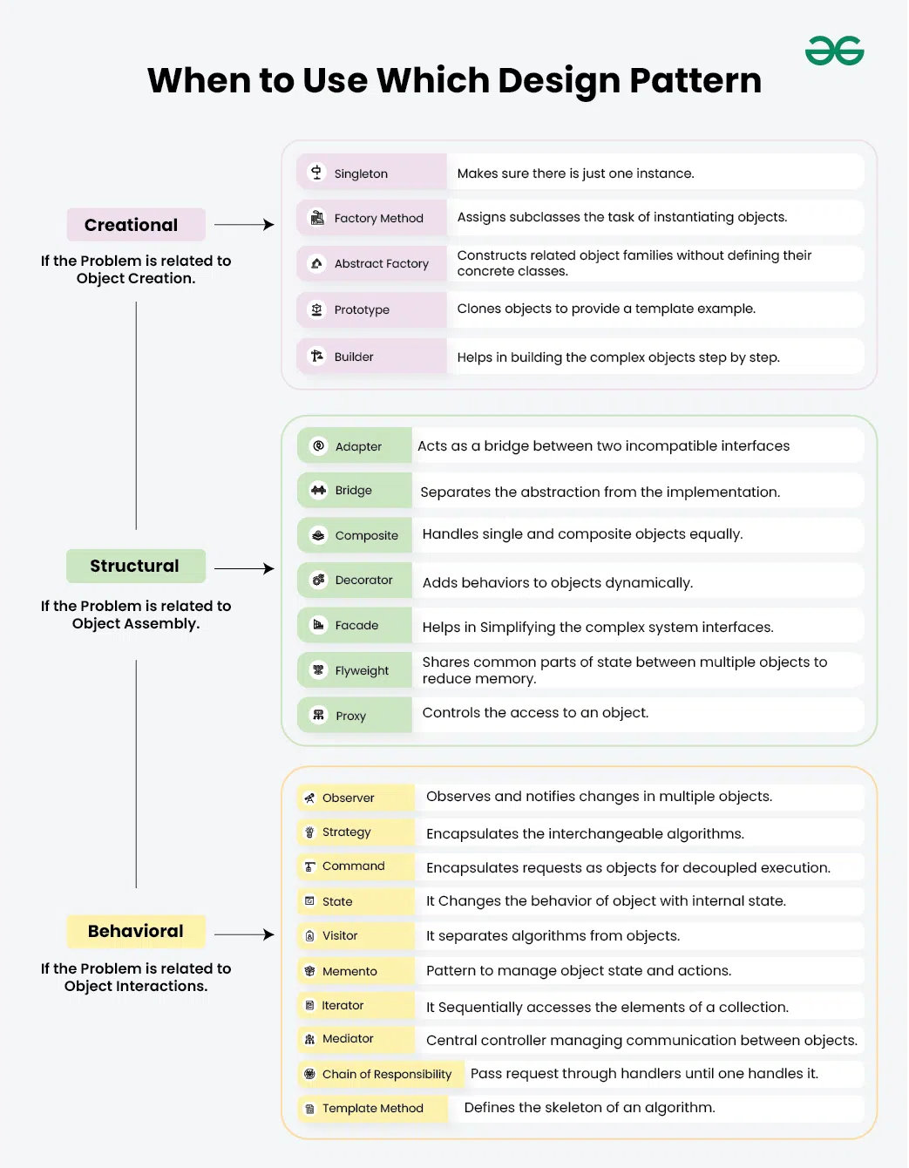



**When to Use Design Patterns**

While design patterns offer numerous benefits, it’s crucial to understand when and how to apply them effectively. Here are some guidelines for using design patterns:

**1. When Solving Common Design Problems**

Design patterns are most useful when you encounter problems that have been solved many times before. If you’re facing a common design challenge, chances are there’s a pattern that addresses it. For example:

* Use the Singleton pattern when you need to ensure that a class has only one instance and provide a global point of access to it.
* Apply the Observer pattern when you have a one-to-many dependency between objects, where multiple objects need to be notified when one object changes state.
* Implement the Strategy pattern when you want to define a family of algorithms, encapsulate each one, and make them interchangeable.

**2. When Improving Code Flexibility and Maintainability**

Design patterns can significantly enhance the flexibility and maintainability of your code. Use them when you want to:

* Decouple components of your system to reduce dependencies
* Make your code more modular and easier to extend
* Improve the readability and understandability of your codebase

**3. When Communicating Design Ideas**

Design patterns provide a common vocabulary for developers to discuss and document software designs. Use them when you want to:

* Communicate complex design concepts more easily with your team
* Document the architecture of your system in a standardized way
* Onboard new team members more quickly by referring to well-known patterns

**4. When Refactoring Legacy Code**

Design patterns can be particularly useful when refactoring legacy code. Use them when you want to:

* Improve the structure of existing code without changing its external behavior
* Introduce more flexibility into a rigid codebase
* Reduce code duplication and improve overall code quality

**Examples of Design Patterns in Action**

Let’s explore some common design patterns and see how they can be implemented in practice.

**Singleton Pattern**

The Singleton pattern ensures a class has only one instance and provides a global point of access to it. This is useful for managing shared resources or coordinating system-wide actions.

|  |
| --- |
| // Singleton class  public class Singleton {  // Static variable to hold the single instance  private static Singleton instance;  // Private constructor to prevent instantiation from outside  private Singleton() {  // Initialization code here  }  // Public method to provide access to the instance  public static Singleton getInstance() {  if (instance == null) {  instance = new Singleton();  }  return instance;  }  // Example business logic method  public void someBusinessLogic() {  // ...  }  }  // Usage  public class SingletonDemo {  public static void main(String[] args) {  Singleton s1 = Singleton.getInstance();  Singleton s2 = Singleton.getInstance();  System.out.println(s1 == s2); // Output: true  }  } |

**Factory Method Pattern**

The Factory Method pattern provides an interface for creating objects in a superclass, but allows subclasses to alter the type of objects that will be created. This is useful when a class can’t anticipate the type of objects it needs to create.

Here’s an example of the Factory Method pattern in Java:

|  |
| --- |
| // Product interface  interface Claim {  void process();  }  // Concrete Products  class HealthClaim implements Claim {  public void process() {  System.out.println("Processing health claim...");  }  }  class VehicleClaim implements Claim {  public void process() {  System.out.println("Processing vehicle claim...");  }  // Factory class  class ClaimFactory {  public static Claim getClaim(String type) {  switch (type.toLowerCase()) {  case "health":  return new HealthClaim();  case "vehicle":  return new VehicleClaim();  default:  throw new IllegalArgumentException("Unknown claim type");  }  }  }  public class FactoryDemo {  public static void main(String[] args) {  Claim claim1 = ClaimFactory.getClaim("health");  Claim claim2 = ClaimFactory.getClaim("vehicle");  claim1.process(); // Output: Processing health claim...  claim2.process(); // Output: Processing vehicle claim...  }  } |

**Observer Pattern**

The Observer pattern defines a one-to-many dependency between objects so that when one object changes state, all its dependents are notified and updated automatically. This is useful for implementing distributed event handling systems.

|  |
| --- |
| // Subject class  import java.util.ArrayList;  import java.util.List;  class Subject {  private List<Observer> observers = new ArrayList<>();  public void addObserver(Observer observer) {  observers.add(observer);  }  public void removeObserver(Observer observer) {  observers.remove(observer);  }  public void notifyObservers(String data) {  for (Observer observer : observers) {  observer.update(data);  }  }  }  // Observer interface  interface Observer {  void update(String data);  }  // Concrete Observer class  class ConcreteObserver implements Observer {  @Override  public void update(String data) {  System.out.println("Received update: " + data);  }  }  // Usage  public class ObserverPatternDemo {  public static void main(String[] args) {  Subject subject = new Subject();  Observer observer1 = new ConcreteObserver();  Observer observer2 = new ConcreteObserver();  subject.addObserver(observer1);  subject.addObserver(observer2);  subject.notifyObservers("Hello, observers!");  }  } |

**Best Practices for Using Design Patterns**

While design patterns are powerful tools, it’s important to use them judiciously. Here are some best practices to keep in mind:

**1. Understand the Problem First**

Before applying a design pattern, make sure you fully understand the problem you’re trying to solve. Don’t force a pattern onto a problem just because you’re familiar with it. The pattern should naturally fit the problem at hand.

**2. Keep It Simple**

Always strive for simplicity in your designs. If a simpler solution works just as well, prefer it over a more complex design pattern. Remember, the goal is to solve problems efficiently, not to showcase your knowledge of patterns.

**3. Consider the Trade-offs**

Every design pattern comes with its own set of trade-offs. For example, while the Singleton pattern provides a global point of access, it can make unit testing more difficult. Always weigh the benefits against the potential drawbacks before implementing a pattern.

**4. Combine Patterns When Appropriate**

Often, the best solutions come from combining multiple patterns. For example, you might use the Factory Method pattern to create objects, and then use the Observer pattern to notify other parts of your system when these objects change state.

**5. Document Your Use of Patterns**

When you implement a design pattern, make sure to document it clearly in your code comments or design documentation. This helps other developers (including your future self) understand the reasoning behind your design choices.

**6. Stay Updated**

Design patterns evolve over time, and new patterns emerge to address modern software development challenges. Stay updated with the latest trends and best practices in software design.

**Common Pitfalls to Avoid**

While design patterns are valuable tools, there are some common pitfalls to be aware of:

**1. Overuse of Patterns**

Don’t try to fit design patterns into every aspect of your code. Overusing patterns can lead to unnecessary complexity and reduced readability. Use patterns where they provide clear benefits.

**2. Misapplying Patterns**

Using the wrong pattern for a given problem can lead to more issues than it solves. Make sure you understand both the problem and the pattern thoroughly before implementation.

**3. Ignoring the Context**

Design patterns are not one-size-fits-all solutions. Always consider the specific context of your project, including performance requirements, scalability needs, and team expertise.

**4. Premature Optimization**

Don’t apply complex patterns in anticipation of future needs that may never materialize. Start with simple designs and refactor to patterns when the need becomes clear.

**5. Neglecting SOLID Principles**

Design patterns should be used in conjunction with, not instead of, fundamental design principles like SOLID (Single Responsibility, Open-Closed, Liskov Substitution, Interface Segregation, and Dependency Inversion).

**Conclusion**

Design patterns are powerful tools in a developer’s arsenal, offering tested solutions to common software design problems. By understanding various design patterns and when to apply them, you can create more robust, flexible, and maintainable software systems.

Remember that design patterns are guidelines, not strict rules. They should be adapted to fit your specific needs and used in conjunction with other software design principles and best practices. As you gain experience, you’ll develop a better intuition for when and how to apply these patterns effectively.

Continuous learning and practice are key to mastering design patterns. Experiment with different patterns in your projects, analyze their impact, and learn from both successes and failures. Over time, you’ll build a deep understanding of how to leverage design patterns to create elegant and efficient software solutions.

By incorporating design patterns into your development process, you’ll not only improve the quality of your code but also enhance your ability to communicate complex design ideas and solve challenging software engineering problems. As you progress in your coding journey, design patterns will become invaluable tools in your quest to become a more effective and proficient developer.